Invited( ), Oral( ), Poster( )

Title 16pt bold Times. Center on page
<one blank line spacing, 10pt>
Authors, 12pt Times^{1,*}C, presenter by underline, corresponding author by*.
<one blank line spacing, 10pt>
Names of all organizations, identified by superscripted numbers
Address (only the address of the first author(presenter))
Email address of the corresponding author 10 pt Times, centered, denoted by*.
<one blank line spacing, 10pt>
<one blank line spacing, 10pt>
Body of abstract in 12 pt Times. Single space. Aligned both sides (double justification). No line spacing between paragraphs. (Microsoft Word automatically adds a little space for aesthetics – auto line spacing.) Indent paragraphs using four spaces.
References and notes should be denoted by numbers in square brackets[4-6] and listed below the body text. The whole document should have a paper size of ‘A4’ which will be reduced for printing in the book of abstracts. Paper margins are 2.5 cm top, bottom left and right. Place figures and tables in the body text centered on page.

Note that the abstract should be written in the English or Korean language.
<one blank line spacing, 10pt>
<one blank line spacing, 10pt>
[1] References in 10 pt Times

Invited ( ), Oral ( O ), Poster ( ) 작성 예

Measurement of absolute thickness of ultra-thin oxide films by mutual calibration method

Gil Dong Hong¹, Gam Chan Kang², Sun Shin Lee^{3,*}

¹ Korea Research Institute of Standards and Science, ²Goguryeo University, ³Hansan University
¹Surface Analysis Team, KRISS (267 Gajeong-ro, Yuseong-gu, Daejeon 34113 Korea)
*sslee@hansan.ac.kr

Thickness measurement of HfO₂ films has been studied by a CCQM pilot study of Surface Analysis Working Group (SAWG). The thicknesses of the HfO₂ films were measured by XPS, XRR, TEM, Ellipsometry, X-ray Fluorescence (XRF), Rutherford Backscattering Spectrometry (RBS) and Medium Energy Ion Scattering Spectrometry (MEIS) from 11 national metrology institutes (NMIs) and 2 individual laboratories.
The thicknesses of the HfO₂ films grown by atomic layer deposition were measured by a MEIS system of KRISS with a time of flight (TOF) analyser. The film thicknesses were determined from the MEIS intensity ratios of the film material and substrate Si (I_{Hf}/I_{Si}) as shown in Figure 1(a) by mutual calibration of the MEIS intensity ratios and the thicknesses by XRR or TEM.[1]
In P-190, the reference thicknesses of the HfO₂ films grown by atomic layer deposition were determined by mutual calibration between the thickness by MEIS and the average thickness by XRR reported in the pilot study P-190. The reported results were linearly fitted to the reference thicknesses as shown in Figure 1(b).[2]
(a) | (b)
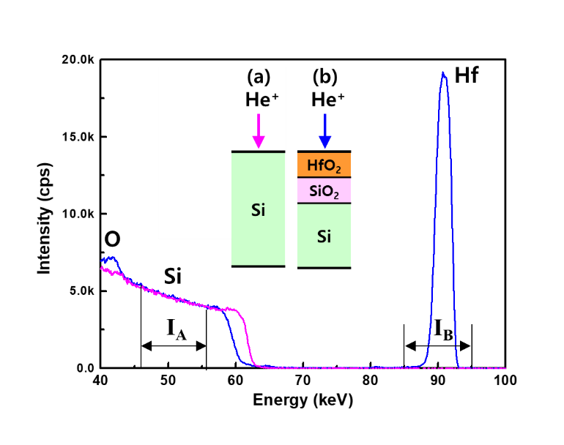 | 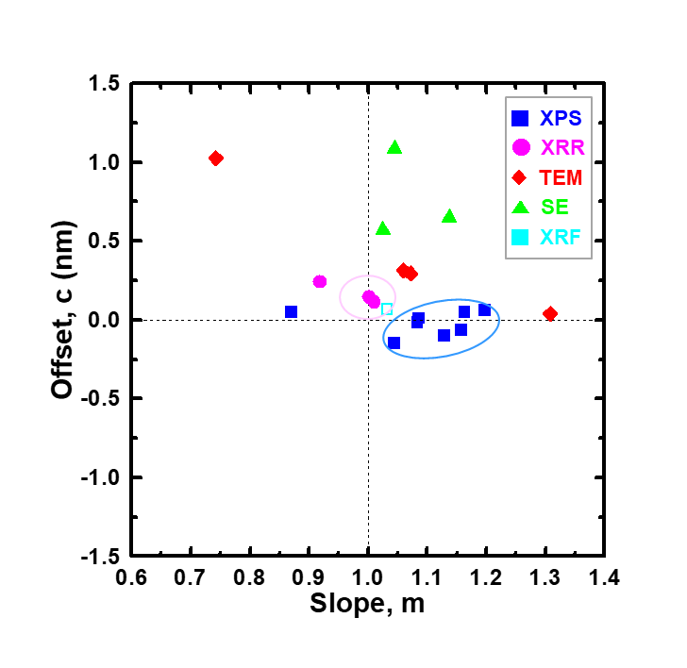
Figure 1. (a) Thickness measurement by MEIS and (b) linear fitting results of P-190 to the reference thicknesses determined from MEIS and XRR.

[1] K. J. Kim, T. G. Kim, J-H. Kwon, H. Ruh, K. Park and W. J. Min, Metrologia 57 (2020) 025001
[2] K. J. Kim, et al., Metrologia 58 (2021) 08016

